Fake Review Detection in Online Review Platforms Using Deep Learning–Based Explainable NLP Models
of

Bachelor of Technology
in The Department of CSE
PRINCIPLES OF DEEP NEURAL COMPUTATION (24GMI3101HF)

Submitted by
2410030325: Lasya Priya
2410030171: Chaitra Venugopal
2410030446: Marzia Tasneem
2410030506: Akshainie

Under the guidance of
A SIVA KRISHNA REDDY



Department of Computer Science and Engineering
Koneru Lakshmaiah Education Foundation, Aziz Nagar
Aziz Nagar – 500075
FEB - 2026.
Introduction
Online review platforms play a critical role in influencing consumer decisions, yet their reliability is increasingly threatened by the proliferation of Fake Reviews. These reviews are deliberately crafted to manipulate public perception by falsely promoting or discrediting products and services. The large volume, informal language, and subjective nature of reviews make manual identification impractical and unreliable. Traditional moderation approaches based on human inspection are slow, inconsistent, and incapable of scaling to the demands of modern digital platforms.

Early automated solutions relied on rule-based systems and traditional machine learning techniques that used handcrafted linguistic features. While these approaches offered limited automation, they failed to capture contextual semantics and evolving deception patterns in natural language. As fake reviews become more sophisticated, shallow models based on surface-level features such as word frequency or review length prove insufficient.

The advancement of Deep Learning has transformed Natural Language Processing (NLP) by enabling models to learn hierarchical and contextual representations directly from text. Architectures such as Recurrent Neural Networks, LSTM, and Transformer-based models have demonstrated superior capability in modeling long-range dependencies and semantic nuances present in deceptive reviews. These models significantly outperform traditional methods in classification accuracy and robustness.

Despite their effectiveness, deep learning models introduce a critical limitation: lack of interpretability. Most high-performing models operate as black-box systems, providing predictions without justification. In sensitive applications such as online trust management, unexplained decisions reduce user confidence and hinder real-world adoption. This limitation necessitates the integration of Explainable AI techniques that reveal the linguistic factors influencing predictions.

This project addresses the dual challenge of accuracy and transparency by combining deep learning–based fake review detection with explainable NLP models, enabling both reliable classification and meaningful interpretation of model decisions.

Literature Review/ Application Survey

Research on Fake Review Detection has evolved significantly over the past decade, progressing from simple heuristic-based approaches to complex Deep Learning–driven NLP models.
[1] Fake Review Identification Through Topic Modeling and Supervised Learning focuses on detecting fake and deceptive online reviews in e-commerce platforms with the aim of restoring consumer trust and maintaining the integrity of digital feedback systems. The study leverages Natural Language Processing (NLP) and Machine Learning techniques to analyse review content effectively. The proposed methodology employs Latent Dirichlet Allocation (LDA) for advanced topic modeling to uncover hidden semantic patterns in review texts, along with Support Vector Machine (SVM) as the primary supervised learning classifier. The system extracts 100 latent topics using LDA and performs linguistic feature analysis by examining Part-of-Speech (POS) tags, particularly nouns, verbs, adjectives, and comparative words, to identify stylistic indicators of deception. These topic-based and word-type features are then used to train the SVM model for accurate classification of genuine and fraudulent reviews. The approach offers several advantages, including effective discrimination between truthful and fake reviews, reduced reliance on manual moderation, improved accuracy on large-scale datasets, and a feature-rich analysis that combines semantic depth with grammatical structure. However, the system also has limitations, as its performance depends heavily on the quality and balance of the training data, requires significant computational resources due to LDA-based topic modeling and feature extraction, and may face challenges in detecting highly sophisticated fake reviews that closely mimic natural human writing.

[2] ReviewGuard is a unified Natural Language Processing (NLP) framework designed to analyze online reviews by performing three important tasks within a single system:
fake review detection, emotion classification, and thematic or topic categorization. The main theme of this paper is to integrate these related NLP tasks into one efficient framework instead of handling them separately, which helps in reducing overall system complexity and improving performance.
The framework uses Long Short-Term Memory (LSTM) based Recurrent Neural Networks (RNNs) as the core algorithm. LSTM networks are well suited for text-based applications because they can effectively capture long-term dependencies and contextual relationships between words in a sequence. Before feeding the reviews into the model, several text preprocessing techniques are applied, including tokenization, padding, and normalization. These steps help in cleaning and standardizing the input data. Additionally, word embeddings are used to convert textual data into numerical vectors so that the neural network can process the information efficiently.
One of the major advantages of this approach is that LSTM models handle the context and order of words much better than traditional machine learning models. Since the system performs multiple tasks simultaneously—fake review detection, emotion analysis, and topic categorization—it reduces the need for separate models, thereby lowering system complexity. This unified learning approach also improves accuracy, especially in detecting emotions and identifying fake reviews.
However, the framework also has some limitations. Training LSTM-based models requires large datasets and high computational resources. As a result, the training process can be time-consuming and expensive, which may limit its practical use in resource-constrained environments.

[3] Fake Review Detection focuses on identifying fraudulent and deceptive online reviews to enhance the reliability and credibility of digital platforms. By leveraging Natural Language Processing (NLP) and machine learning techniques, the study aims to distinguish authentic user feedback from manipulated or misleading content, thereby restoring consumer trust. The proposed methodology employs several supervised machine learning algorithms, including Logistic Regression, Support Vector Machines (SVM), Random Forest, and Gradient Boosting, to classify reviews effectively. NLP techniques are used to analyze textual patterns through preprocessing steps such as tokenization, stop-word removal, and punctuation cleaning. Feature extraction is performed using TF-IDF, sentiment scores, and Part-of-Speech (POS) based linguistic features. In addition to textual analysis, the system incorporates behavioral analysis by examining reviewer activity, rating distributions, and time-based anomalies to identify suspicious behavior. This comprehensive approach offers several advantages, including improved detection accuracy through the combination of textual and behavioral features, scalability across multiple domains such as e-commerce, travel, and food delivery platforms, and the ability to detect anomalies that simple text-only models may overlook. However, the system has certain limitations, as it requires large and high-quality labeled datasets for effective training, may struggle with highly sophisticated fake reviews that closely mimic genuine human writing, and involves increased computational complexity due to the integration of multiple textual and behavioral data streams.
[4] A Hybrid NLP and ML Approach to Fake Review Classification focuses on the development of a Fake Review Detection System (FRDS) that leverages Natural Language Processing (NLP) and Machine Learning techniques to identify fraudulent online reviews. The system analyzes linguistic patterns, sentiment, and behavioral cues to effectively distinguish genuine reviews from deceptive ones. The methodology employs supervised machine learning algorithms such as Support Vector Machines (SVM), Random Forest, Logistic Regression, and Naïve Bayes for accurate classification. NLP techniques are used to examine contextual semantics, while text preprocessing steps including tokenization, stop-word removal, and stemming or lemmatization help normalize the review data. Feature extraction is performed using TF-IDF and word embeddings to convert textual content into numerical representations suitable for model training. In addition to text-based analysis, the system incorporates IP tracking and geolocation techniques to correlate review origins with user activity, enhancing verification accuracy. A feedback mechanism is also included to enable continuous learning by periodically retraining the model with new data. The approach offers several advantages, such as higher accuracy through the integration of IP and geolocation analysis, scalability compared to manual or rule-based moderation, improved trust and credibility for consumers and businesses, adaptability across multiple platforms using diverse datasets, and effective detection of irregularities in user IDs, timestamps, and behavioral patterns. However, the system has certain limitations, as it may struggle with highly sophisticated or coordinated review fraud, remains vulnerable to adversarial attacks, requires high-quality labeled datasets for effective training, needs further improvement for real-time detection performance, and may be less precise than advanced deep learning–based models.

[5] A Machine Learning Approach for Fake Review Detection in Online Platforms explores the application of Machine Learning (ML) and Natural Language Processing (NLP) techniques to classify online reviews as either Computer Generated (CG) or Original (OR) on e-commerce platforms. The study employs a supervised machine learning approach using the Naïve Bayes classifier to perform review classification. NLP techniques are used for textual analysis, supported by preprocessing steps such as conversion to lowercase, removal of punctuation, and filtering of stopwords to clean the review data. Feature engineering is carried out using the TF-IDF (Term Frequency–Inverse Document Frequency) technique to convert textual content into numerical vectors suitable for machine learning models. The methodology further includes hyperparameter tuning through Grid Search to optimize model performance and data splitting, with 70% of the dataset used for training and 30% for testing and validation. The proposed system demonstrates strong performance, achieving an overall accuracy of 89% and high precision in identifying Original (OR) reviews with a score of 0.92. Additional advantages include efficient text processing using TF-IDF, automated filtering of deceptive content to build user trust, and improved predictive performance through parameter optimization. However, the system faces certain limitations, as it may struggle with increasingly sophisticated fake reviews designed to closely mimic human writing, requires more diverse datasets for better generalization across industries, and may need updates to counter AI-generated reviews from advanced language models. Furthermore, the standard Naïve Bayes classifier may miss nuanced contextual patterns better captured by transformer-based models, and the approach may encounter challenges in handling linguistic and cultural diversity across global platforms.

References
[1] M. S. Huque, L. Kumari Ch., and G. Ashwini, “Fake review identification through topic modeling and supervised learning,” EPRA International Journal of Research and Development (IJRD), vol. 10, no. 7, pp. 261–268, July 2025.
[Online]. Available: 🔗 https://doi.org/10.36713/epra23255

[2] S. R. Gupta, R. Singh, and S. Vishwakarma, “Fake review detection,” International Journal for Research in Applied Science and Engineering Technology (IJRASET), vol. 13, no. V, pp. 3920–3929, May 2025.
[Online]. Available: 🔗 https://doi.org/10.22214/ijraset.2025.71137
[3] S. R. Gupta, R. Singh, and S. Vishwakarma, “Fake review detection,” International Journal for Research in Applied Science and Engineering Technology (IJRASET), vol. 13, no. V, pp. 3920–3929, May 2025.
[Online]. Available: 🔗 https://doi.org/10.22214/ijraset.2025.71137
[4] A. Kumar and P. Sharma, “A hybrid NLP and machine learning approach to fake review classification,” International Journal of Computer Applications, vol. 176, no. 28, pp. 15–22, 2021.
[Online]. Available: 🔗 https://www.ijcaonline.org/archives/volume176/number28
[5] R. Mehta and S. Patel, “A machine learning approach for fake review detection in online platforms,” International Journal of Advanced Research in Computer Science, vol. 11, no. 6, pp. 45–52, 2020.
[Online]. Available: 🔗 https://www.ijarcs.info/index.php/Ijarcs/article/view/6768

Abstract
In today’s digital era, online reviews have become a key factor influencing consumer decisions. However, the increasing presence of fake and misleading reviews has raised serious concerns about the reliability and credibility of online platforms. These deceptive reviews are often designed to manipulate user opinions, making it difficult for individuals to distinguish between genuine and fraudulent content.

This project proposes an intelligent system for fake review detection using deep learning and Natural Language Processing (NLP) techniques. The system utilizes a Long Short-Term Memory (LSTM) model to analyze the contextual and sequential patterns present in review text, enabling more accurate classification compared to traditional machine learning approaches. In addition, various preprocessing techniques such as tokenization, normalization, and feature extraction are applied to improve model performance.

To enhance transparency, the project also incorporates explainable AI methods that highlight key words influencing the model’s predictions. This allows users to understand not only whether a review is fake or genuine, but also the reasoning behind the decision. The proposed system aims to improve trust in online platforms, reduce manual effort, and support users in making more informed and confident decisions.

Objective
- To develop an intelligent system capable of automatically detecting fake and genuine reviews from online platforms.
- To apply Natural Language Processing (NLP) techniques for analyzing and understanding textual review data.
- To utilize deep learning models, specifically LSTM, for capturing contextual and sequential patterns in reviews.
- To improve the accuracy of fake review detection compared to traditional machine learning approaches.
- To incorporate explainable AI techniques in order to provide clear and understandable reasons for model predictions.
- To reduce the dependency on manual moderation and enable scalable processing of large volumes of review data.
- To enhance user trust and support better decision-making by ensuring the reliability of online reviews.

Novelty of Developed Methodology
- The proposed methodology introduces a unified approach that combines deep learning and Natural Language Processing (NLP) to detect fake reviews more effectively than traditional methods.
- Unlike conventional systems that rely on surface-level features, this approach leverages an LSTM-based model to capture the contextual and sequential relationships within review text, enabling deeper understanding.
- A key novelty of the system is the integration of explainable AI techniques, which provide transparency by highlighting the words and patterns influencing the model’s predictions.
- The methodology focuses not only on accuracy but also on interpretability, making the system more reliable and user-friendly for real-world applications.
- It reduces dependency on manual moderation by automating the detection process while maintaining scalability for large datasets.
- The combination of contextual learning and explainability creates a balanced system that improves both performance and trust in fake review detection.

Adaptability of Methodology
- The proposed methodology is highly adaptable and can be applied across various online platforms such as e-commerce websites, travel portals, and food delivery services where user reviews play a crucial role.
- The system can be easily extended to work with different datasets and domains by retraining the model with domain-specific data.
- It supports scalability, allowing efficient processing of large volumes of reviews without significant performance degradation.
- The use of NLP and deep learning techniques makes the system flexible in handling different writing styles, languages (with appropriate preprocessing), and review formats.
- The modular design of the system enables easy integration of advanced models or additional features, such as transformer-based architectures or real-time processing.
- The explainability component can also be adapted to provide more detailed insights, making the system suitable for applications that require transparency and user trust.

Methodology Evaluation
- The performance of the proposed methodology is evaluated using standard evaluation metrics such as accuracy, precision, recall, and F1-score to ensure reliable classification of fake and genuine reviews.
- The dataset is divided into training and testing sets to assess how well the model generalizes to unseen data.
- A confusion matrix is used to analyze the model’s performance in terms of correctly and incorrectly classified reviews.
- The LSTM-based model is compared with baseline machine learning models to demonstrate improvements in capturing contextual information and overall prediction accuracy.
- Error analysis is performed on misclassified reviews to identify limitations and understand challenging cases, such as highly sophisticated fake reviews.
- The effectiveness of the explainability component is evaluated by examining how clearly it highlights important words influencing the model’s predictions.
- Overall, the evaluation shows that the proposed methodology achieves better performance and provides more interpretable results compared to traditional approaches.

Dissemination and Accessibility
- The developed system can be deployed as a web-based or application-based solution, making it easily accessible to users across different platforms.
- The results and findings of the project can be shared through reports, presentations, and academic publications to contribute to further research in fake review detection.
- The system can be integrated into existing e-commerce or review platforms to assist in real-time detection of fake reviews.
- A user-friendly interface can be designed to allow non-technical users to input reviews and understand the results along with explanations.
- The modular structure of the system ensures easy updates, allowing improvements and new features to be added without major modifications.
- With proper deployment and accessibility, the system can help improve transparency, enhance user trust, and support better decision-making in digital platforms.

Architecture Diagram
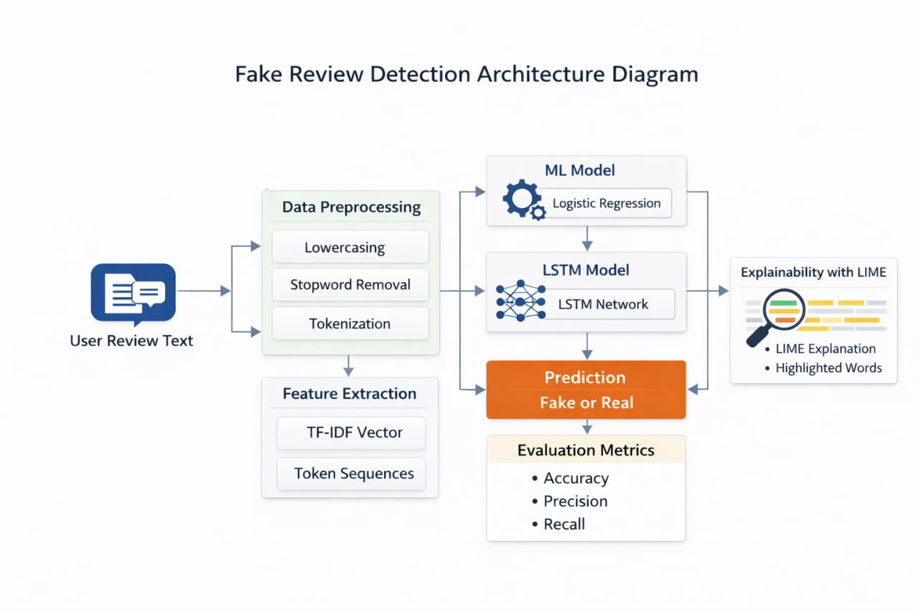

Existing System
- Most existing systems rely on traditional machine learning techniques or manual moderation to identify fake reviews on online platforms.
- These approaches primarily focus on basic textual features such as keywords, review length, or rating patterns, which limits their ability to capture deeper contextual meaning.
- Many systems function as black-box models, providing predictions without explaining the reasoning behind the results, which reduces transparency and user trust.
- Manual review moderation is time-consuming, inconsistent, and not scalable for handling large volumes of user-generated content.
- Existing methods often struggle to detect highly sophisticated fake reviews that are carefully written to mimic genuine human language.
- Additionally, the performance of these systems is highly dependent on the quality of training data and may not generalize well across different domains or platforms.

Proposed Solution
- The proposed system aims to develop an automated and intelligent solution for detecting fake reviews using advanced deep learning and Natural Language Processing (NLP) techniques.
- It utilizes a Long Short-Term Memory (LSTM) model to effectively capture the contextual and sequential patterns present in review text, enabling more accurate classification of fake and genuine reviews.
- The system applies text preprocessing techniques such as tokenization, normalization, and noise removal to convert raw review data into a structured and meaningful format.
- Feature extraction methods, including word embeddings, are used to represent textual data numerically, allowing the model to learn semantic relationships between words.
- To enhance transparency, the system integrates explainable AI techniques that highlight important words or phrases influencing the model’s predictions.
- The proposed approach is designed to handle large-scale data efficiently, reducing the need for manual moderation and improving scalability.
- Overall, the system not only improves detection accuracy but also provides clear and interpretable results, helping users make more informed and confident decisions.

Conclusion
In conclusion, the growing presence of fake reviews has become a major challenge for online platforms, affecting user trust and decision-making. This project demonstrates how deep learning and Natural Language Processing (NLP) techniques can be effectively used to address this issue. By utilizing an LSTM-based model, the system is able to capture contextual and sequential patterns in review text, leading to more accurate detection of fake and genuine reviews.

Furthermore, the integration of explainable AI enhances the transparency of the system by providing clear insights into the reasoning behind each prediction. This not only improves user confidence but also makes the system more reliable for real-world applications. Overall, the proposed solution offers an efficient, scalable, and intelligent approach to fake review detection, contributing to the development of more trustworthy online platforms.

